**WALCHAND INSTITUTE OF TECHNOLOGY, SOLAPUR**

**DEPARTMENT OF ELECTRONICS AND TELECOMMUNICATION ENGINEERING**

**Year 2023-2024**

**Project Synopsis**

1. Name of the Project **: Interactive toolkit for Machine Learning**
2. Name of Students : Name
3. Samarth Rajanikant Kurnurkar (Group Leader)
4. Rohan Sunil Safar
5. Aditya Sunil Shinde
6. Name of the Guide : Prof. P.D.R. Patnaik
7. Whether Project is Sponsored : No
8. Introduction and Purpose of Project: **Integrating Machine Learning Programs on Raspberry Pi with Linux OS**
9. Problem Statement : Overcome challenges related to compatibility between machine learning libraries, frameworks, and the Raspberry Pi's Linux operating system.
10. Purpose : The primary purpose of this project is to demonstrate the integration of machine learning programs within the Raspberry Pi's Linux environment, offering a good opportunity for the students
11. Objectives of the Project:

1. Integration with Raspberry Pi

2. Accuracy and Reliability

3. Real-Time Inference

1. Scope/ Limitations of the Project : 1. Dependence on Training Data

2. Hardware Compatibility

3. Unbalanced Data

1. Brief Description/Methodology of the project :

Flowchart :

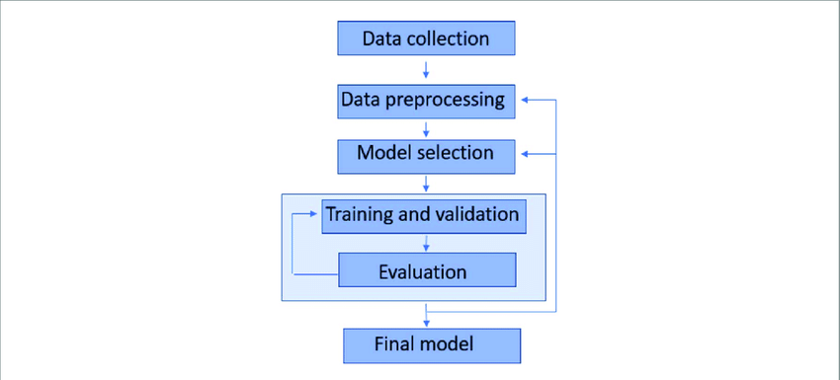

The project titled "Interfacing of ML Programs in Raspberry Pi using Linux OS" focuses on the integration of Machine Learning (ML) programs with the Raspberry Pi platform using the Linux operating system. With the rapid growth of IoT applications and the increasing demand for embedded systems capable of executing complex tasks, the project aims to provide a seamless framework for deploying and running ML algorithms on a Raspberry Pi.

**Block Diagram :**

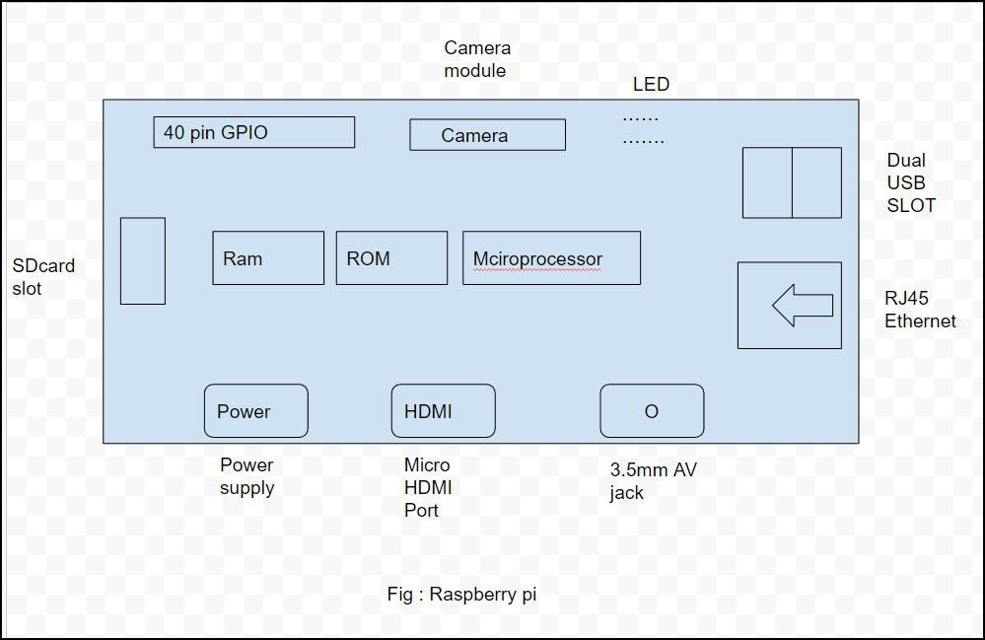

1. Likely H/W components required & S/W platform/ packages required :

H/W : 1) Raspberry Pi

2) Touch Display

S/W: 1) Linux OS

2) VS Code

Name & Signature Dr. Ms. A.V. Thalange

Project Guide Head, E&TC Engg.